100 Friends in 100 Hours
There are a few ways to be successful with this fundraiser – a Facebook event and/or an e-mail campaign.
The best way to start this is by having a “FACEBOOK EVENT”
A Facebook Event can be like having a party, but you don’t have to buy food and beverages for or clean up after! It only takes 5 minutes to set it up, and a lot of posting throughout the “party.”

Here is how you do it:
- Log into Facebook on your computer (on your phone it gets more confusing!)
- Click on the + sign in the upper right hand corner:
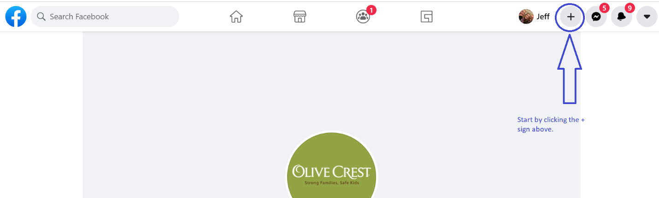
- Next click on the EVENT button:
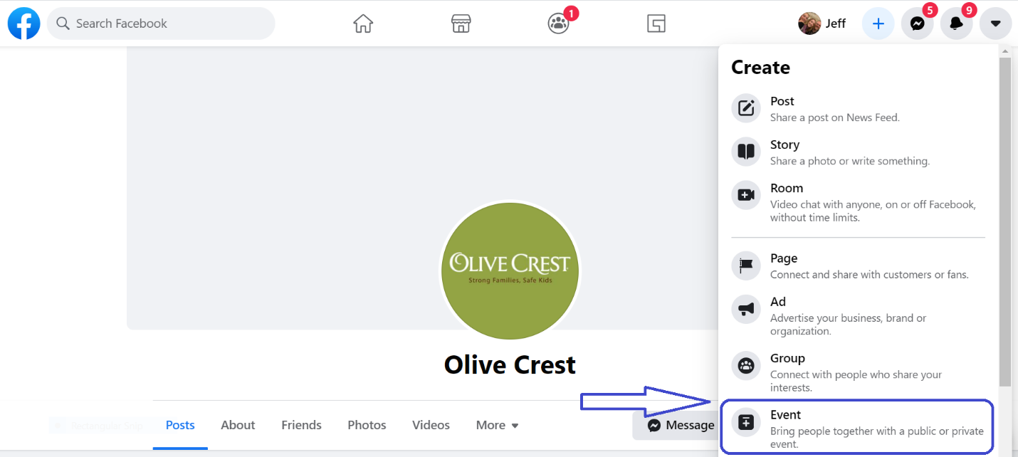

- Click Online event option, then fill in the details
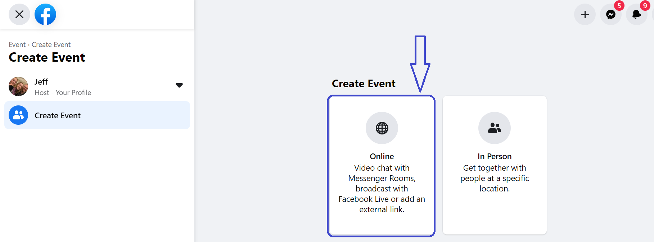
- Name: “100 Friends in 100 Hours”
- Details: This is where you explain what you are doing and how you want people to help. See sample language below. Insert your website link!
- When: 100 hours is 4 days and 4 hours, so if you start on a Thursday at 5pm you will finish on Monday at 9pm
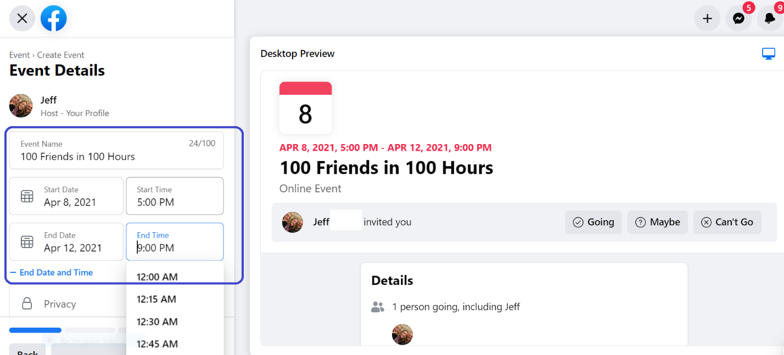
- Once you click create it will take you to your event page. You can continue to customize and edit to your heart’s content. Add pictures to your event and check the details to make sure all your information is correct.

- Invite all your Facebook Friends! Once they are a part of your event – they will automatically see all your updates over the next 100 hours!! (Make sure to invite your fundraising captain as well so she can support you with tips and tricks along the way)
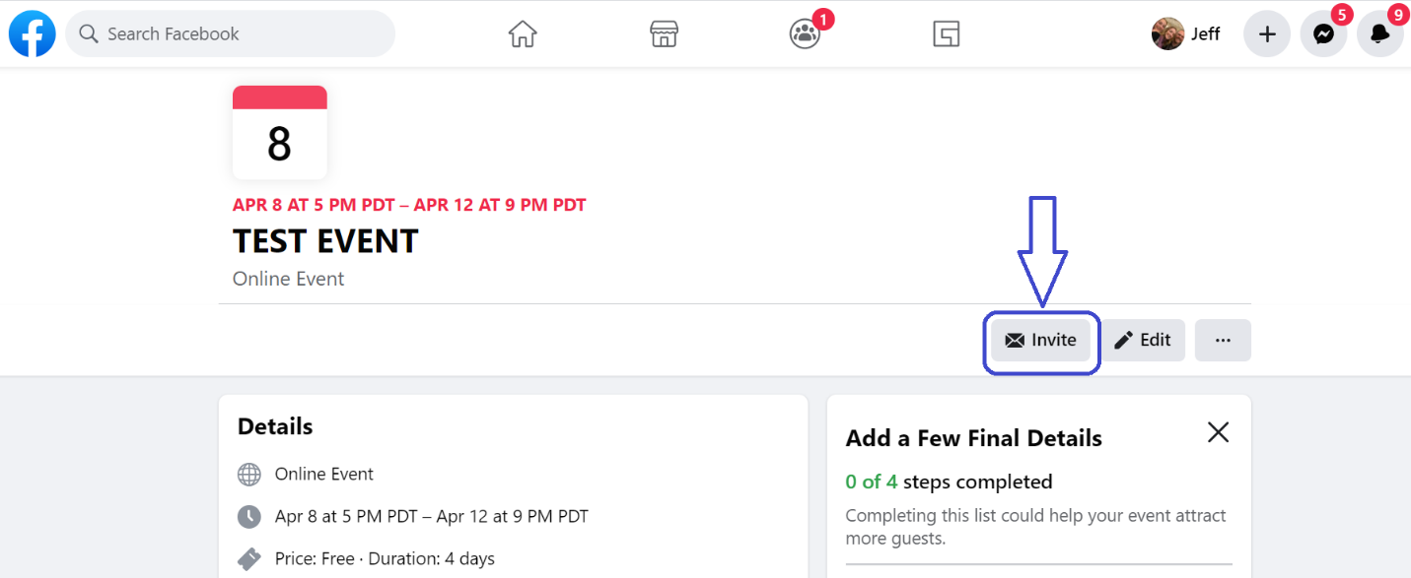
- Update, thank, and tag your donors OFTEN on Facebook!
- HAVE FUN!!! This is a virtual party!!!
- Think of fun incentives you can give…maybe bake brownies for the first person to donate or the 27th or the 99th? Raffle off small prizes at random milestones.
- Pit groups of friends against each other! Who is going to have more donations – your college friends or your co-workers?
- Ask your friends to invite their friends…this is how you get donations from people you have never met!!
- Do a countdown every few hours “I only need 30 more donations and I have 42 hours left.”

Sample Language for Details Section:
I am looking for 100 friends to join with me in taking a stand saying Child Abuse Stops Here®! In the next 100 hours, I am looking for 100 donations. I don't care how large or how small your donation is, I just want 100 people to get involved!
All donations can be made at: (Insert your weblink here)
In the next 100 hours I’m going to be sharing facts and stories and I hope that will encourage you to get involved! I am kicking of the challenge at 5pm Thursday, April 8th and going through 9pm on Monday April 12th.
There will also be prizes, drawings and incentives along the way because I want this to be fun for everyone!
(Customize this to share why you are supporting Olive Crest) …
Every dollar counts!
Think of it like this:
$2.00 – I went and checked my couch cushions and found some spare change, so it’s all yours!
$5.00 – I‘ll donate to the cause instead of heading to Starbucks today
$20.00 – I found that spare $20 in my jeans I didn’t even knew I had!
$50.00 – I heard a rumor that the bigger the donation the more entries I would get in the raffle
$100.00 - I really really want to win a prize (and support a great cause)
$?????? – I march to the beat of my own drum so I’m going to be original with my donation amount.

Stay tuned for more info facts, stories and info on chances to win some great prizes! The first prize will be raffled off when I get ____ new donations!
Thank you for all your love, support and friendship!
Important Notes for you Facebook Event:
- Every time someone donates post a picture of that person (ideally with you) and thank them and tell a little anecdote as to how you know them. People LOVE this!! If you have a picture with the donor and a number of other friends, use that picture and tag all the friends in the picture – it will encourage the others to donate.
- You have to be committed to the 100 hour period. Be on standby to find pictures and post a thank you ASAP. This is a good reason to have at least part of you 100 hours be over a weekend period.
- Make the event fun. Post fun facts and stories throughout the 100 hours. Engage your friends in the conversation. Tell people about the stories that motivate you to help Olive Crest. It all encourages people to join in the fun.
- I recommend including a Friday in your 100 hours, since for most people Friday = PayDay!

EMAIL CAMPAIGN
Facebook is only one component. Send out emails telling everyone that your goal is to get the most number of donations in the next 100 hours…no donation is too small or too LARGE.
Here’s how you do it:
Send a fundraising message like the one below to 100 or more friends and family – especially those who are not on Facebook:
Hi-
I’ve been challenged to kick-start my fundraising campaign for Olive Crest by asking 100 friends to each donate at least $10 (can put a higher amount if you’d like) to Olive Crest in the next 100 hours.
At the end of the week my teammates and I will find out who received the most number of donations (of any amount) and I would really like to win! Skip that latte tomorrow morning and donate taking a stand saying Child Abuse Stops With Me! Or skip it for a week and donate even more!
Please use the link in this email to donate online quickly and securely. Donations are 100% tax deductible.
(INSERT YOUR FUNDRAISING PAGE LINK HERE!!!)
I’m raising this money for Olive Crest an organization dedicated to child abuse prevention. My personal fundraising goal is $________. Every donation at every amount ($10, $20, $50… it all adds up) will bring us closer to our goals and will take a stand saying that Child Abuse Stops Here®.
On behalf of Olive Crest and the children and families they serve, thank you very much for your donation. I appreciate your generosity.

For the children,

STEP 2: Send a follow-up using the template below (2—3 days after the original message)
Hi-
Just a reminder that my "100 friends, 100 hours" competition is still on! Have you made your donation yet to say that Child Abuse Stops With Me?
Please use this link to make a donation to Olive Crest now:
(INSERT YOUR FUNDRAISING PAGE LINK HERE!!!)
I’d love for you to see a short video of the story of one of the (children/families) that Olive Crest was able to help thanks to generous people like you:
INSERT VIDEO HERE
Did you know that Olive Crest serves over 27,000 children and families each year, just like Sally (name made up but use name of video selected).
Giving even a small donation makes a big difference in preventing child abuse. No donation is too small or too large!

Thank you for your generosity and support!

